**Day 3 - API Integration Report - Eshop**

* First, placed the migration file(of template 6) in my nextjs project.
* Created a sanity project.
* Set up the sanity project in my nextjs project through the cli command.
* Setted the projectId and token in the importData.js file.
* Run the following command to import the data: node importData.js
* Run the nextjs project and goto studio route.
* In vision write the following query to check that the data is imported:
* *[_type == “product”]
* The data imported successfully.
* Now check the fields name in the imported data and correct the schema so that name of both fields matches.
* Fetch the products data in nextjs project through client.fetch(‘query’).
* Displayed the fetched data in the frontend.
* The end point of provided api is /products.

API CALL

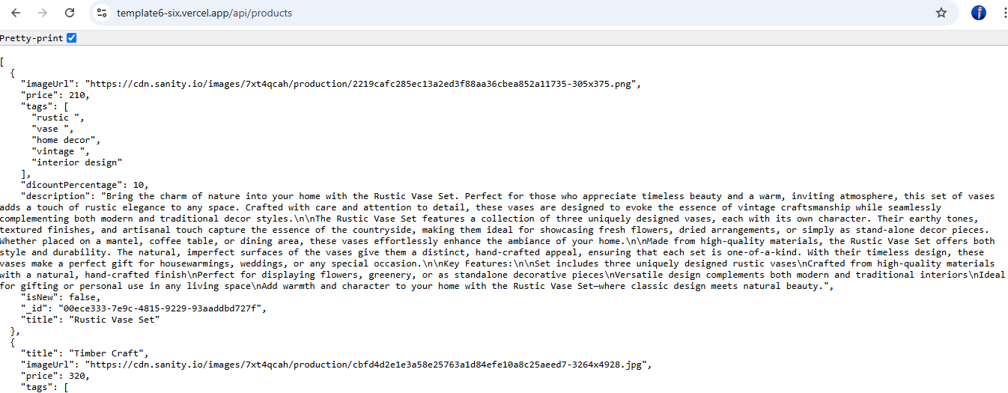

**Imported data displayed successfully in the frontend:**

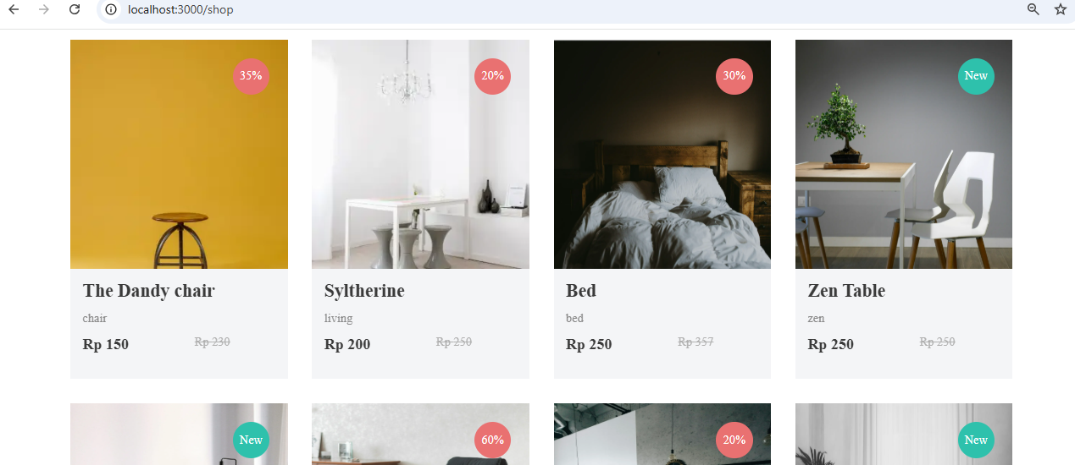

**Populated Sanity CMS fields:**

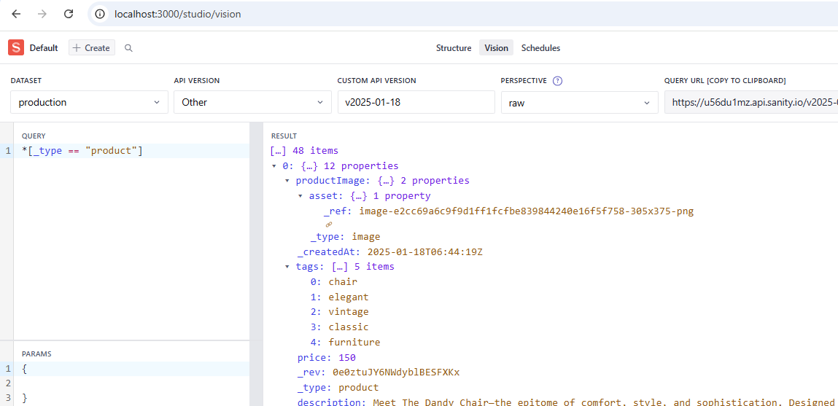

**Type of data:**

